Advanced Robotics - Week 1

Module introduction & Learning from Humans

Dr Paul Baxter – Module Coordinator



1. Advanced Robotics Module

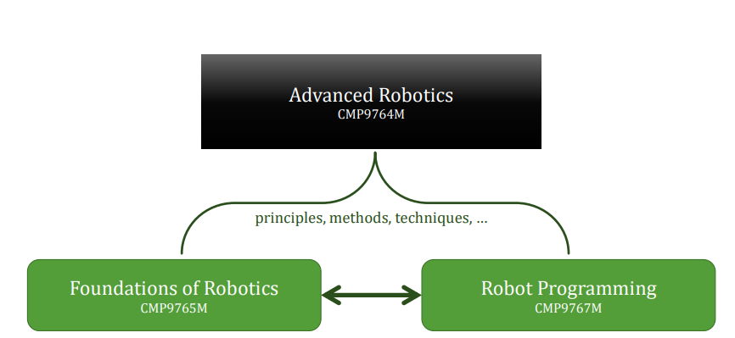

Synopsis

This module focuses on “**advanced**” concepts in robotics.

We will introduce **navigation** and state estimation for mobile robots and discuss optimality principles and relevant algorithms for **path planning**, **trajectory optimization** and control for **robot manipulators**. In the second part of the module, we will discuss data-driven approaches that can **learn** from human teachers and **interaction** with the environment.

To deepen the understanding of the introduced mathematical concepts, practical examples will be discussed in the lectures as well as implemented in the workshops

Learning Objectives

* LO1 **Analyse the “state of the art” in advanced robotics**, including an understanding of the mathematical principles and current applications
* LO2 **Critically appraise a range of advanced concepts** for navigation, state estimation, planning, learning and control, identifying their strengths and weaknesses, and selecting appropriate methods to serve particular roles
* LO3 **Design a software component** for solving complex robot control problems for mobile robotics or robot manipulators

Dr. Amir Ghalamzan

* Associate Professor in Lincoln Institute for Agri-food Technology (LIAT).
* Member of L-CAS.
* Research interests include robotic grasping and manipulation, agri-food robotics, teleoperation, shared control, variable autonomy, robot learning from demonstration and surgical robotics.

[aghalamzanesfahani@lincoln.ac.uk](mailto:aghalamzanesfahani@lincoln.ac.uk)

<https://staff.lincoln.ac.uk/0c09165e-bd6d-473d-93ce-4fceb583d722>

Dr. Athanasios Polydoros

* Lecturer in Robotics and Autonomous Systems.
* Member of L-CAS.
* Research interests and expertise includes robot learning, machine learning applied to robot control, learning from demonstration, and reinforcement learning.

[apolydoros@lincoln.ac.uk](mailto:apolydoros@lincoln.ac.uk)

<https://staff.lincoln.ac.uk/99d1bfa4-2d7f-4a30-9a81-3de5a3a495f2>

Dr. Paul Baxter

* (module coordinator)
* Senior Lecturer in Computer Science
* Member of L-CAS and ARIC
* Research interests include human-robot interaction (child-robot interaction), educational robotics, human-inspired cognitive robotics, HRI methodology

[pbaxter@lincoln.ac.uk](mailto:pbaxter@lincoln.ac.uk)

<https://staff.lincoln.ac.uk/4e5d4601-928f-429f-a1ea-4e39a555a968>

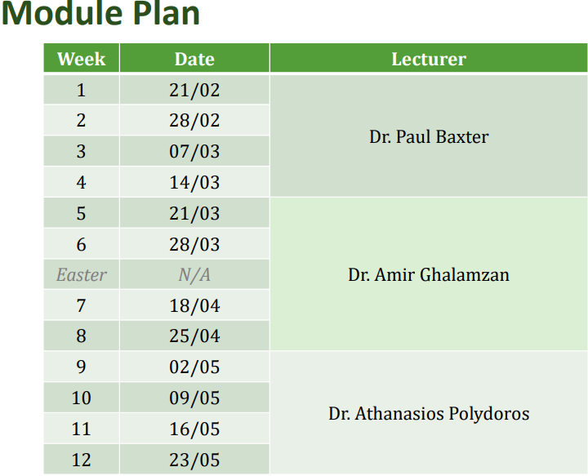

Assessment

100% Assignment (portfolio) No exam

* Choose two assignments from the three available
* Roughly aligned with the three topics covered in the module by the three members of the delivery team
* Will be introduced by the member of the delivery team
* Combination of written, research, and practical work(A report Style)
* 3 assignments in total each from a different lecturer, pick 2/3 and submit them.

Submission through Blackboard

* Submission deadline, for all assignments on this module, on the SoCS hand-in spreadsheet

Material from workshops will not be explicitly assessed, however, this may help significantly with the relevant parts of the assignment…

2. Learning from Humans

* HRI
* Interactive ML
* Consequences, ethics, etc.

Learning from Humans

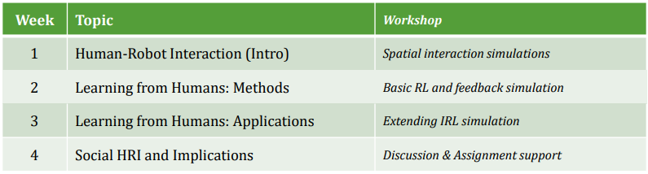

* Can only be a brief look at some of the topics involved in HRI…
* Purpose of workshops is to get some hands-on practice with the concepts we cover in lectures.

Examples, applications, some code, possibly a discussion or two…

* Workshop tasks will build on some of the topics you have encountered previously, but can be studied independently.
  + Refer to previous code/methods if you have these available to you.

Human-Robot Interaction

Purpose of robotics:

* Automation: doing (boring/repetitive) jobs for people
* Replacing people in risky/dangerous situations
* …

Could also use for helping people:

* Physical rehabilitation (exoskeletons, haptics, etc)
* Social therapy, etc (e.g. socially-assistive robotics - SAR)
* …

And as a tool for understanding people…?

The psychology/social science perspective The interaction of humans and robots is pervasive in robotics -> hence HRI…

Human-Robot Interaction (HRI) is: … a field of study dedicated to understanding, designing, and evaluating robotic systems for use by or with humans. Interaction, by definition, requires communication between robots and humans.

<http://humanrobotinteraction.org/1-introduction/>

Origins of HRI lie in HCI

* Particularly in terms of development and evaluation methodologies

Aspects of HRI

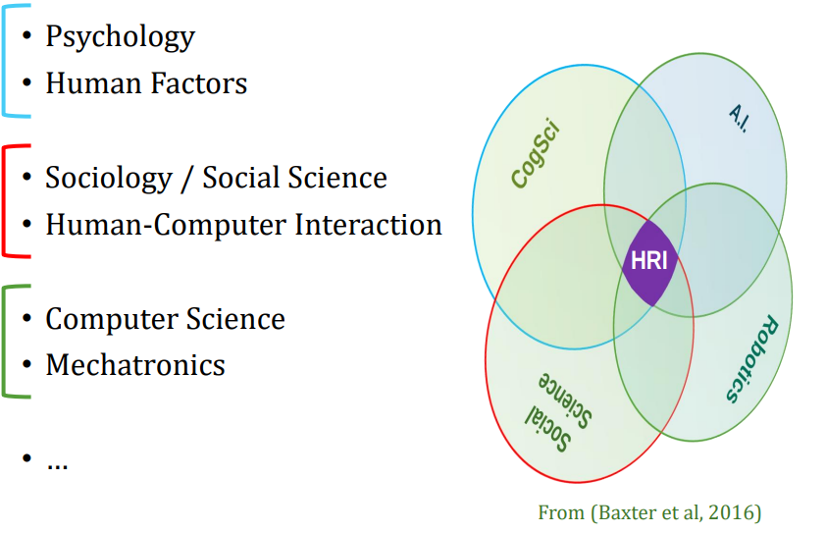

Decision Making: What is Autonomy?

Implicit assumption so far that our robots are autonomous

* Or working towards autonomy

Many (very involved) definitions that are philosophicallyinclined…

* E.g. based on autopoiesis…

Practical characterisations:

<http://humanrobotinteraction.org/autonomy/>

The amount of time that a robot can be ‘neglected’ by the designer/operator

* High autonomy: long periods acting on its own
* Low autonomy: no/short periods of acting alone

Levels of Autonomy

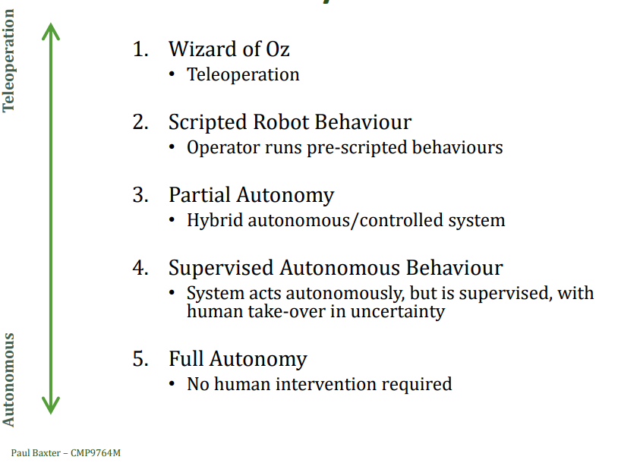

Learning from Humans

Increasing autonomy of robots for interaction with people by learning from people.

What can we get from humans?

Humans are pretty good examples of autonomous behaviours in complex environments, social environments, with complex yet (on occasion) sparse feedback…

Two ways of doing this:

1. Learning from humans in general

* General characteristics of people in terms of psychology, physical properties, etc

Learning from humans through interaction

* Learning directly from humans, in terms of skills, expertise, knowledge, etc

Human-Aware Spatial Interaction

A case study in learning from General Human Behaviour

Mobile robots and people

Many robots you have come across so far in the MSc have been mobile (on wheels), and have typically been expected to operate in environments along-side humans

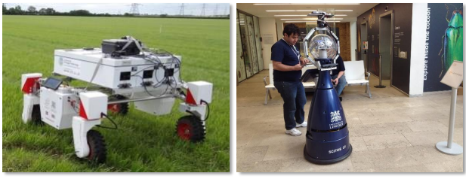

The questions therefore is: can navigation/planning/positioning be achieved taking the human into account safely and effectively?

Humans are not just obstacles…

Human-Robot Spatial Interaction The study of joint movement of robots and humans through space and the social signals governing these interactions

* Movement of robots and humans
* Focus on social signals

Human-Aware Navigation

* Specifically taking the human into account
* Three goals: comfort, naturalness, and sociability
* Two main methods:
  + 1. “Stop-and-wait”: human does all the hard work
  + 2. Cost functions based on principles of Proxemics

Human-Robot Spatial Interaction

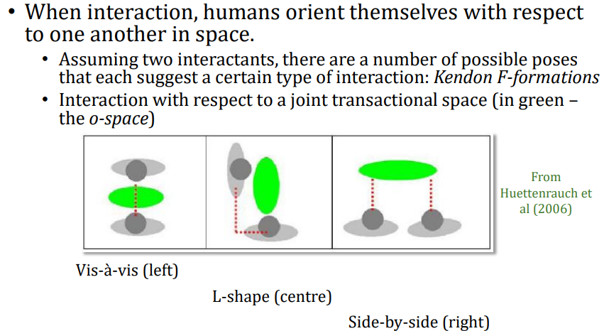

F-spaces

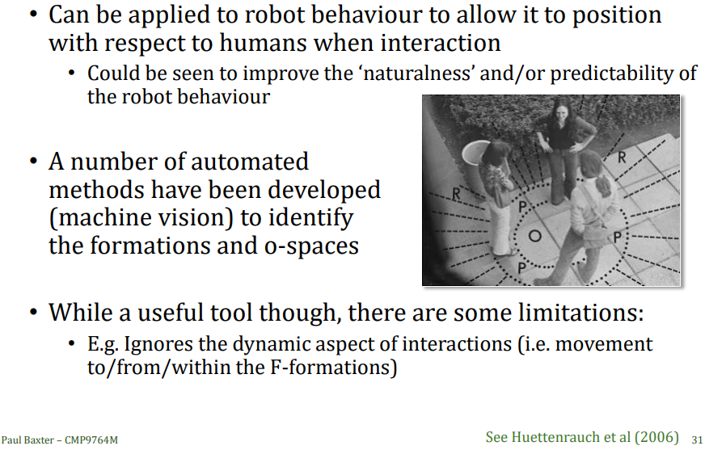

Adam Kendon’s *Facing Formation*, mostly known as *F-formation*.

Human-Aware Navigation

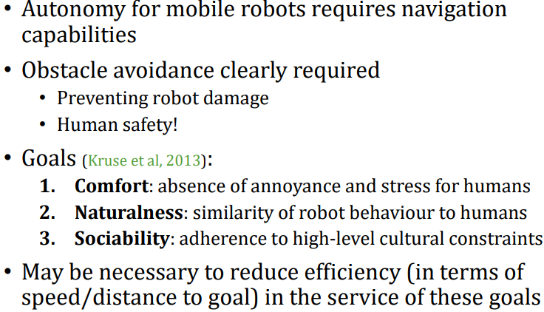

Example

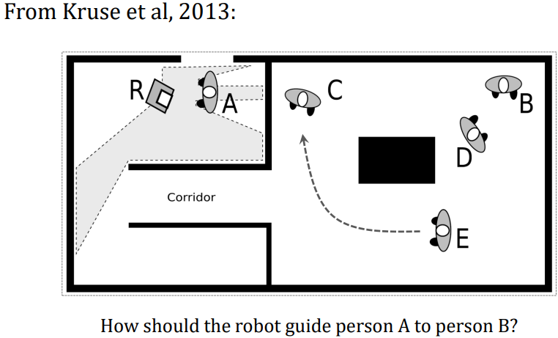

Humans are Awkward Obstacles…

<https://www.youtube.com/watch?v=zdnvhQU1YNo>

Cost maps and path Planning

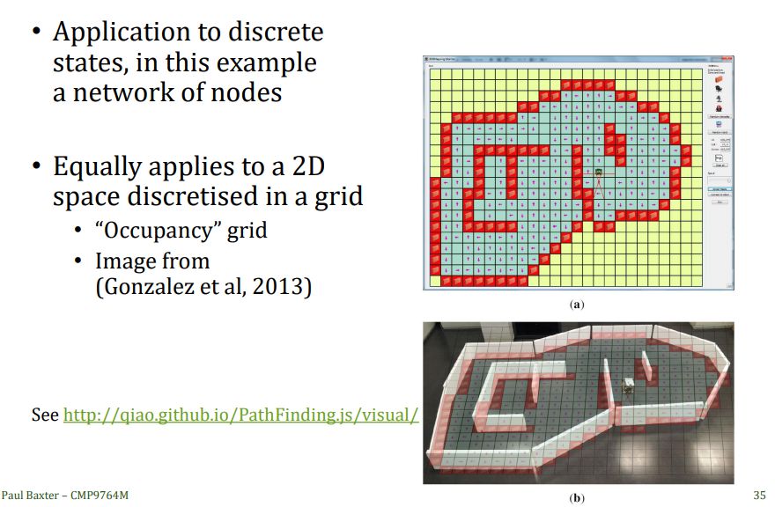

<http://qiao.github.io/PathFinding.js/visual/>

Derivation of costmaps from robot size

See the following ROS description:

<http://wiki.ros.org/costmap_2d>

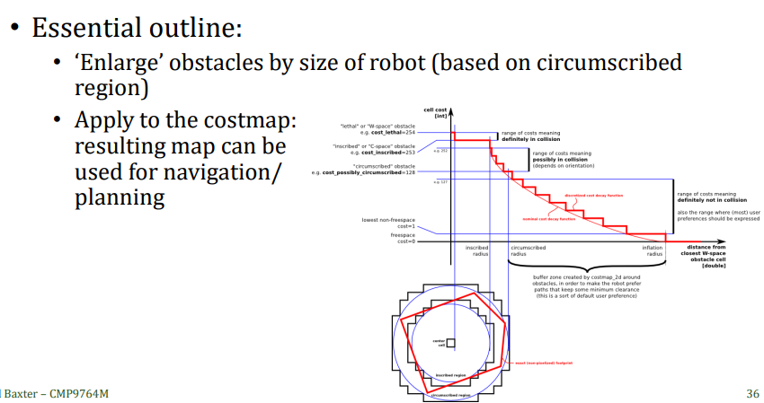

Proxemics

A virtual personal space around an individual

* Edward Hall, 1966

Divided into four main zones

* Each zone at a different distance, and with different interaction characteristics
* Also dependent on relationship
* Two ‘phases’ per zone

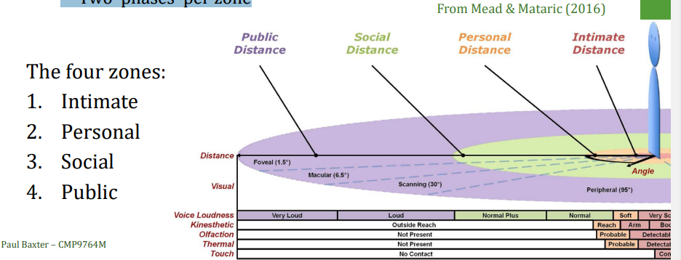

Combining Costmaps and Proxemics

Including costmaps as part of the human representation in the map:

* Including proxemics as part of this
* What is the benefit?

Keeping a greater distance to the human

* Perceived as safer
* Reduced stress
* Even though less “efficient”

Not necessarily either of the other two goals

* Doesn’t guarantee more natural behaviour
* Doesn’t incorporate societal/cultural norms (e.g. drive on the left or the right?)

How to put Proxemics into Costmap?

Proxemic space as a 2D Gaussian

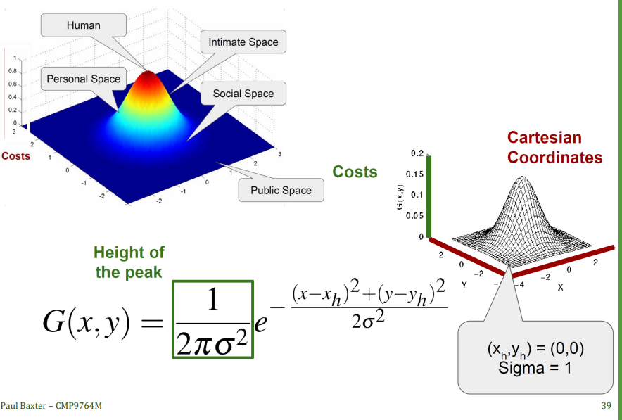

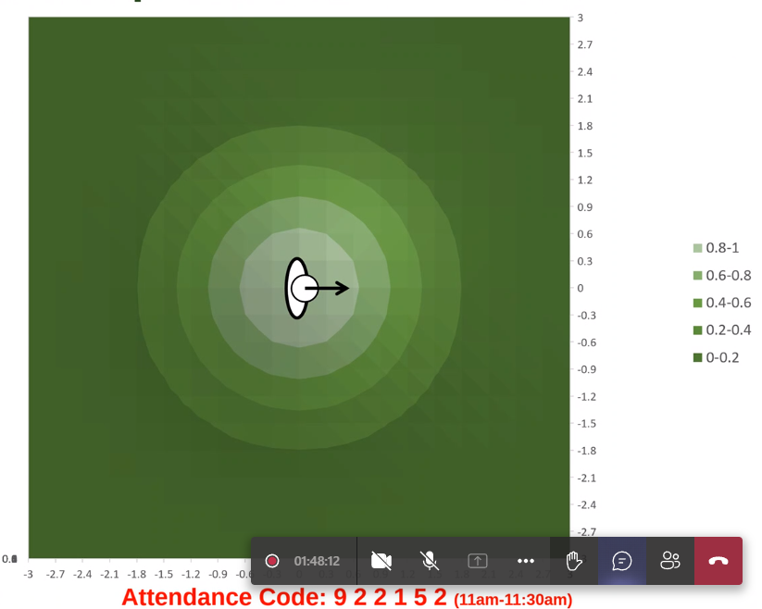

Representing a person as a 2d Gaussian and inflate the costs and associate them with distances to the robot.

Navigating in Open Space

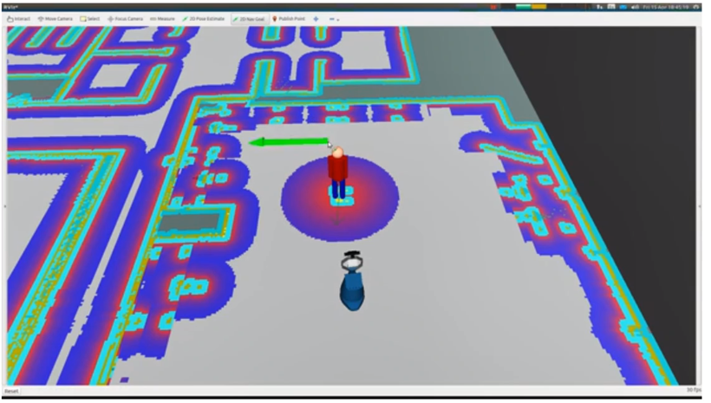<https://www.youtube.com/watch?v=pg7g7qv8OMU>

Layered costmaps

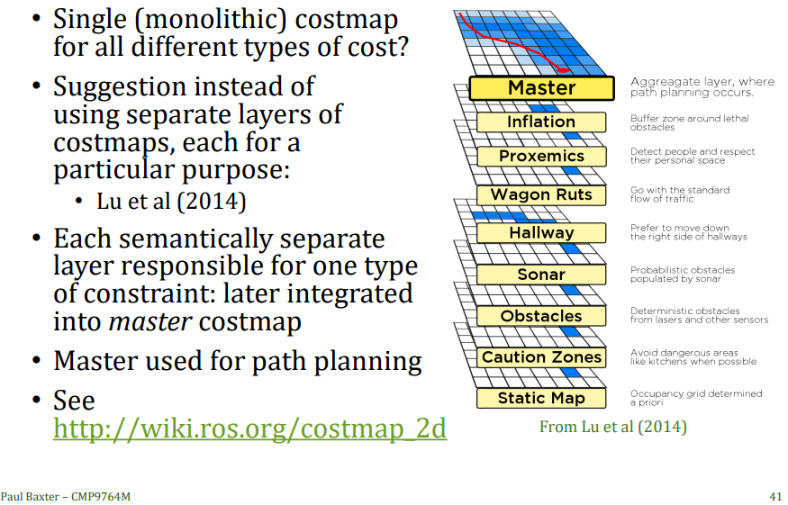

Caveats

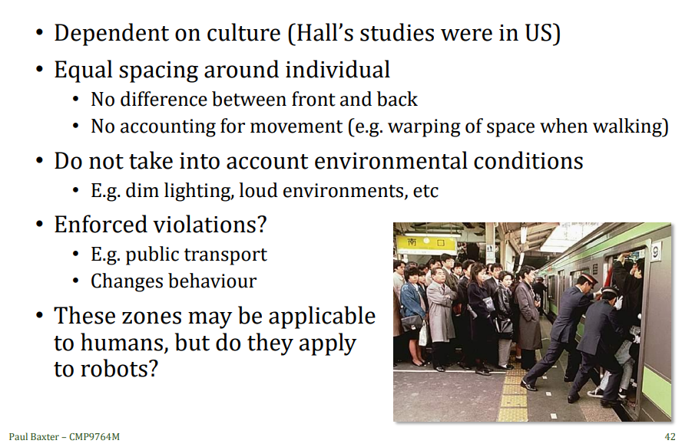

Improving the model

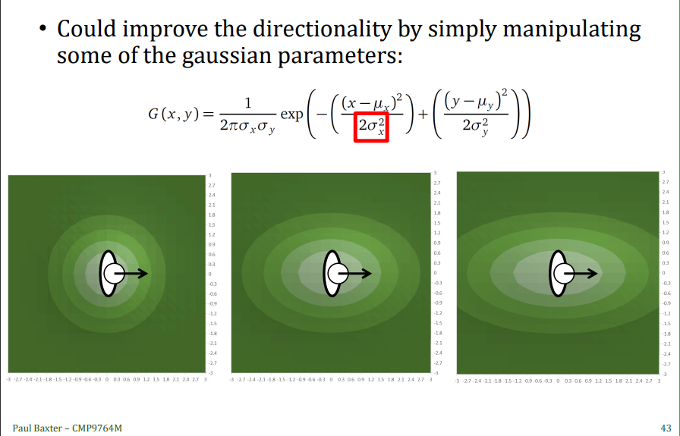

Gaussian Cost functions

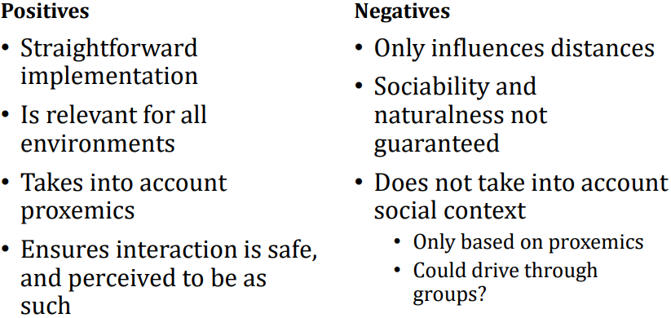

Differences between humans and robots

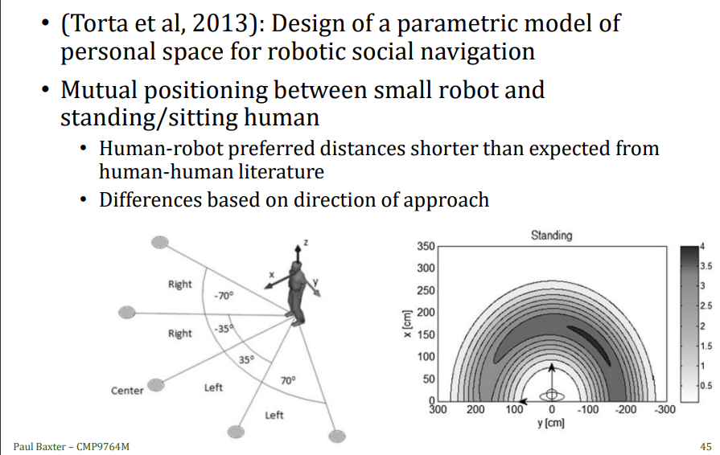

Behaviour for interaction?

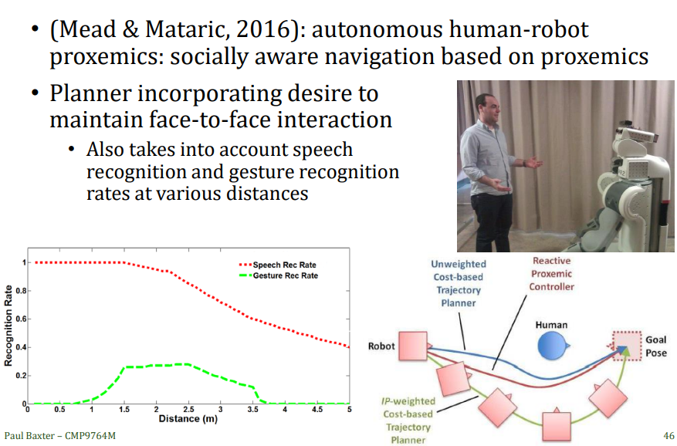

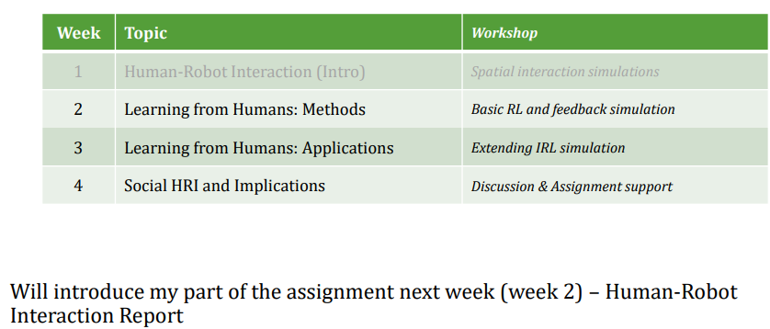

Creating a patch

[How to create a patch - MoodleDocs](https://docs.moodle.org/dev/How_to_create_a_patch)